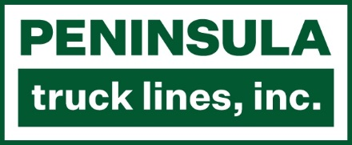
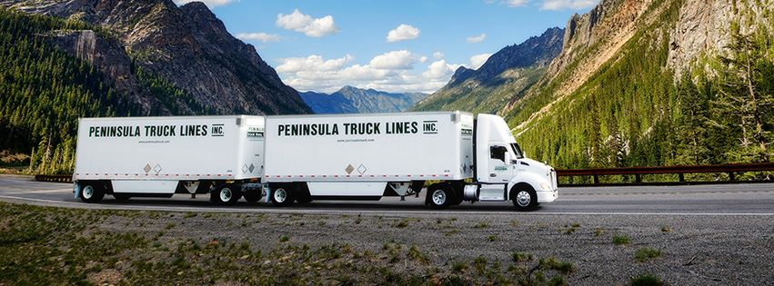
BUSINESS SYSTEMS ANALYST
Information Technology | Federal Way, WA | Exempt, Full-Time
Mission Statement  To provide the highest quality transportation services in the Northwest by exceeding the expectations of our customers, employees and community.  Our Vision  Excellence in every transaction  Our Principles  - Conduct business following the highest ethical standards  - Provide our customers with total satisfaction  - Foster an environment of mutual respect and teamwork among our employees  - Provide a safe and healthy work environment  - Regard vendors as partners in business  - Support and contribute to our country and the communities we serve  - Profitability is essential to ensure our success | Job Summary  Our company was founded with the promise that every delivery is handled with care for the customer and care for the customer’s freight. As a people-centric organization, the needs of our customers and employees are the forefront of our operations.  As a Business Systems Analyst at Peninsula Truck Lines you'll design, implement and maintain systems that support the highest quality transportation services in the Northwest.  This role supports the Company’s mission by serving as a strategic leader seeking new, improved and innovative ways to support the efficiency, effectiveness, and reliability of business processes and business systems.  Key Responsibilities  - Determine strategic and operational objectives by studying business functions, analyzing existing systems and highlighting areas of improvement.  - Document business and systems requirements through stakeholder interviews, observation, and other fact-finding techniques.  - Diagram processes, model data, evaluate systems alternatives, and recommend solutions.  - Design business systems or modifications by analyzing requirements, constructing workflow diagrams, studying system inputs/outputs, and writing design specifications.  - Define project requirements by identifying project milestones, phases, and establishing a project budget.  - Monitor project progress by tracking activity, resolving problems, publishing progress reports, and recommending actions.  - Coordinate and oversee system development as per the requirement specifications.  - Provide references by writing and maintaining user documentation and system documentation.  - Validate the functionality of the end product according to the requirement specifications.  - Facilitate system deployments, configuration changes, data conversion and user training.
- Monitor business systems performance, discover variances and propose necessary actions.
- Maintain confidentiality and security about the information being processed, stored or accessed by the business systems.
- Provide help desk support and ongoing technical user training for enterprise applications.
- Will perform other duties as assigned.
Skills & Qualifications
Education:
- 3+ years’ experience in enterprise information technology environment preferred.
- Prior transportation experience is preferred, LTL trucking highly desirable.
- Bachelor degree in Computer Science, Information Systems, or Business Management required or equivalent proven experience.
- Certification in Business Analysis or Project Management desired.

Knowledge, Skills and Abilities:
- Must possess a high degree of integrity and trust.
- Excellent analytical ability, natural curiosity and problem-solving aptitude.
- Project or program management experience required.
- Outstanding interpersonal and tailored communication skills.
- Ability to set priorities, meet deadlines and multi-task with minimal supervision.
- Thorough understanding of the SDLC in waterfall and agile methodologies.
- Previous experience learning and owning enterprise applications/business systems.
- Expertise in MS Office tools and Business Process Analysis/Management tools.
- Demonstrated analytical, deductive reasoning and troubleshooting skills.
- Demonstrated customer service skills and the ability to interact with personnel at all levels of the organization.

Physical Requirements & Work Environment:
- Constant sitting at a desk with repetitive hand movements to operate a computer for long periods of time.
- Ability to bend below waist level to adjust operating hardware on occasion.
- Ability to travel to, and move about in, field locations.
- Ability to occasionally work non-traditional or extended hours based on business need.
- Ability to read, write, speak and comprehend conversational English.
Employment & Benefits
Reports to: VP of Information Technology
Status: Full Time, Exempt
Location: Federal Way, WA with occasional travel to regional terminals
Compensation: Competitive base salary commensurate with experience
Benefits: Employer-sponsored medical insurance for employee and dependents; Health Savings Account (HSA); Flexible Spending Accounts (FSA); 401(k); company paid life insurance and long-term disability insurance; paid time off

Company Purpose
Peninsula Truck Lines provides high-quality transportation services with flexibility and friendliness. Our focus is on making the transportation process simple and stress-free by listening and building trusted relationships with our customers, employees and community.

Our company was founded with the promise that every delivery is handled with care for the customer and care for the customer’s freight. As a people-centric organization, the needs of our customers and employees are the forefront of our operations.
Culture
Peninsula Truck Lines portrays service excellence and openness, as there is a warmth and friendliness that accompanies the company’s interactions with customers, employees and the community. We respect each other as friends. We are down-to-earth and helpful. We are here to exceed the expectations of our customers, employees and the communities we serve.

